The hypomagnetic variable in lunar plant biology
D. Marshall Porterfield1*, Richard, J Barker1, Caue Borlina2, Aubrey O’Rourke2, Adriana Sanchez1, Manisha Dagar1, Sofia Leiva Aldana1, Ray Wheeler3, Gioia Massa4, Barbara Demmig-Adams6, Marta Peirats-Llobet, Pamela Flores, Anirudha Dixit

, (ET AL sign in as a co-author) Christine Chamberlain6

¹ Department of Agricultural and Biological Engineering, Purdue University, West Lafayette, Indiana 47907, USA
²Department of Earth and Planetary Sciences, Purdue University, West Lafayette, Indiana 47907, USA
⁶Space Lab Tech.
*Corresponding Author email: porterf@purdue.edu

Figure 0 | The hypomagnetic variable in lunar plant biology: physical environments, candidate quantum mechanisms, and causal flight validation.
Physical Regimes & Superposition (Left): On Earth and in low Earth orbit (LEO, e.g., the International Space Station), plants develop within a dipolar geomagnetic field (GMF, 25–65 μT25\text{--}65\ \mu\text{T}25–65 μT). Beyond low Earth orbit (BLEO) and on the lunar surface, the planetary dipole is absent, leaving a hypomagnetic field (HMF, <5 nT<5\text{ nT}<5 nT solar wind interplanetary magnetic field to 10–300 nT10\text{--}300\text{ nT}10–300 nT localized crustal paleomagnetism). The net vector sum experienced by a flight specimen is governed by superposition: Btotal(t,x)=Bcrust+Bext+Blander+Bpayload+Bcontrol\mathbf{B}_{\text{total}}(t,\mathbf{x}) = \mathbf{B}_{\text{crust}} + \mathbf{B}_{\text{ext}} + \mathbf{B}_{\text{lander}} + \mathbf{B}_{\text{payload}} + \mathbf{B}_{\text{control}}Btotal (t,x)=Bcrust +Bext +Blander +Bpayload +Bcontrol , where unshielded lander avionics DC currents (50–500 μT50\text{--}500\ \mu\text{T}50–500 μT) and payload subsystems (LED arrays, pumps, fans) can exceed the terrestrial dipole and inadvertently mask lunar hypomagnetic exposure.
Multiscale Mechanisms (Center): Candidate magnetic reception pathways stratified by Quantum Biology Atlas evidentiary tiers: [T1] cryptochrome (CRY1/CRY2) flavoprotein radical-pair spin dynamics ([FAD∙−⋯TrpH∙+][\text{FAD}^{\bullet-} \cdots \text{TrpH}^{\bullet+}][FAD∙−⋯TrpH∙+] singlet-triplet interconversion, coherence lifetime τcoh∼1 μs\tau_{\text{coh}} \sim 1\ \mu\text{s}τcoh ∼1 μs, Zeeman precession νL≈1.4 MHz\nu_L \approx 1.4\text{ MHz}νL ≈1.4 MHz at 50 μT50\ \mu\text{T}50 μT attenuated to <8 kHz<8\text{ kHz}<8 kHz in lunar HMF, cascading through COP1/SPA1 to delay flowering); [T2] organellar bioenergetics, including chloroplast photosynthetic electron transport (Fv/FmF_v/F_mFv /Fm quantum yield and non-photochemical quenching [NPQ] in closed reaction centers) and mitochondrial respiration (alternative oxidase [AOX] cyanide-resistant bypass and iron-sulfur [Fe–S] cluster biogenesis via AtNFS1 and frataxin [AtFH]); and [T3] mitochondrial Complex III QoQ_oQo site semiquinone-Rieske [2Fe-2S] radical pairs, where strong exchange coupling (J∼GHz≫GMFJ \sim \text{GHz} \gg \text{GMF}J∼GHz≫GMF) refutes unphysical runaway superoxide leak models.
Flight Decision Pipeline (Right): A four-stage causal risk-retirement framework for Artemis payloads: (1) In situ triaxial magnetic vector surveying (DC to 10 kHz10\text{ kHz}10 kHz); (2) Ground dose-response sweeps (≤5 nT\le 5\text{ nT}≤5 nT to 50 μT50\ \mu\text{T}50 μT) with bifilar sham controls; (3) Active causal rescue (40–50 μT40\text{--}50\ \mu\text{T}40–50 μT restored inside magnetic shielding); and (4) Predeclared flight decision gates translating empirical phenotypes into mission actions: Green (Nominal: retire flight risk), Amber (Operational Shift: adjust lighting/harvest timeline), or Red (Hazard Mitigation: mandate low-power active bias coils or tolerant cultivars).

Abstract
Lunar plant payloads are designed around radiation, partial gravity, atmospheric control, water and lighting, yet magnetic exposure at the biological volume is rarely specified. Ground studies show that near-null fields can modify development, nutrient homeostasis, redox signaling and photosynthetic performance, but responses are heterogeneous, and the primary sensor remains unresolved. We evaluate the primary literature as part of a mechanistic metanalysis framework that treats magnetic exposure as a controlled variable in the lunar research environment. A key unknow is the potential for synergistic effects from exposure to increased galactic cosmic radiation associated with spaceflight beyond low earth orbit, in the magnetic vacuum outside of the geomagnetic van Allen Belts.
Plants are becoming operational infrastructure for exploration, because they can provide food, oxygen regeneration, carbon dioxide removal, water cycling and psychological benefit, while also serving as sensitive biological sentinels. Plants can also provide some of the critical antioxidant nutrients and electron cofactors for mitochondrial ROS countermeasures, and NASA selected the Lunar Effects on Agricultural Flora (LEAF) payload to understand plant photosynthesis, growth and systemic nutritional antioxidant production in the lunar surface environment.¹ While previous space-plant frameworks have emphasized radiation, reduced gravity, atmospheric composition, water delivery, temperature, lighting, microbiology and resource constraints²⁻³, magnetic exposure now needs to a part of payload requirements for future work on the Moon outside of the terrestrial dynamo magnetic field (25-65μT).
While the available literature does not offer insight into a scenario where lunar hypomagnetic field exposure would catalyze mission experimental failure based on an inevitable quantum biophysical lesion in organellar electron transport, or a quantum-coherent signaling requirement for survival, it does support a critical mechanistic role for the geomagnetic field for normal plant physiology. Studies have shown direct evidence for declines in developmental, reproductive timing, mineral nutrition, redox signaling and photosynthetic performance in some species under hypomagnetic experimental conditions.⁴⁻⁶ This evidence supports a requirement for magnetic exposure to be treated as an incompletely characterized environmental variable whose magnitude, direction, spectrum and interaction with other stressors must be measured and, where feasible, experimentally controlled.
LEAF payload Lunar magnetic field environments
Whereas the terrestrial geomagnetic field is a vector field of approximately 25-65 microtesla at Earth’s surface,⁴ the Moon lacks a comparable present-day global dipole. The Lunar surface, however, is magnetically heterogeneous, with lunar probes Prospector and Kaguya, revealing broad weak-field regions, localized remanent crustal anomalies and surface fields spanning orders of magnitude⁷⁻⁸. The solar-wind, and the earth’s magnetotail and induced fields add temporal variability that cannot be characterized or modeled and would require active sensing of the “lunar field” to define the exposure of the LEAF biological payload.

Therefore. we need to consider all potential inputs to the local magnetic field strength (B):
B_{total}(t,x) = Bc_{rust} + B_{external} + B_{lander} + B_{payload} + B_{control},

Btotal (t,x) =
BCrust = Remanent crustal anomalies (Prospector / Kaguya maps)
Bexternal=Solar-wind, Earth magnetotail and induced flucturations.
Blander= Spacecraft currents, batteries, motors and ferromagnets.
Bplayload= Chamber heaters, fans, valves, and wiring (15-20 nT ripple)
Bcontrol= Active triaxial cancellation, reference coil and u0metal

Where the external term includes solar-wind and magnetotail contributions, and the lander and payload terms include currents, batteries, motors, switching converters, heaters, fans, valves, ferromagnetic materials and permanent magnets. Spacecraft-generated interference is not a minor detail. Measurements from the Korea Pathfinder Lunar Orbiter required correction of approximately 15-20 nanotesla periodic spacecraft signals when natural lunar signals could be only a few nanotesla.⁹ Inside a compact plant chamber, electronics and wiring may therefore dominate the natural field.

Figure 1 | Field Hierarchy and Risk Pipeline
(Panel tags: npj Microgravity = a, b, c; iScience = A, B, C; Life Sciences in Space Research = (a), (b), (c))
Figure 1 | Magnetic field environments, evidentiary hierarchy, and operational risk-retirement pipeline for lunar plant biology.
a, Field Superposition at Biological Volume. Schematic of a lunar surface plant growth enclosure illustrating the environmental and engineered magnetic vectors that superimpose at the specimen canopy: interplanetary magnetic field carried by the solar wind (Bext\mathbf{B}_{\text{ext}}Bext , ∼5 nT\sim 5\text{ nT}∼5 nT), localized lunar crustal remnant fields (Bcrust\mathbf{B}_{\text{crust}}Bcrust , 10–300 nT10\text{--}300\text{ nT}10–300 nT), lander avionics DC battery and power distribution buses (Blander\mathbf{B}_{\text{lander}}Blander , 50–500 μT50\text{--}500\ \mu\text{T}50–500 μT), internal payload actuation components (Bpayload\mathbf{B}_{\text{payload}}Bpayload : circulating fans, fluidic pumps, and LED arrays), and optional active control coils (Bcontrol\mathbf{B}_{\text{control}}Bcontrol ). Inset indicates the placement of a 3-axis fluxgate/magnetoresistive sensor package logging B(t)\mathbf{B}(t)B(t) directly within the canopy headspace. The net vector equation Btotal(t,x)=Bcrust+Bext+Blander+Bpayload+Bcontrol\mathbf{B}_{\text{total}}(t,\mathbf{x}) = \mathbf{B}_{\text{crust}} + \mathbf{B}_{\text{ext}} + \mathbf{B}_{\text{lander}} + \mathbf{B}_{\text{payload}} + \mathbf{B}_{\text{control}}Btotal (t,x)=Bcrust +Bext +Blander +Bpayload +Bcontrol highlights that stray DC magnetic fields from uncharacterized spacecraft systems can inadvertently exceed terrestrial intensity, confounding flight hypomagnetic studies unless explicitly mapped.
b, Quantum Biology Atlas Evidence Hierarchy. The four-tier visual and evidentiary classification framework applied to lunar plant magnetobiology: T1: Demonstrated Field Effect (heavy solid black border, 2.2 pt2.2\text{ pt}2.2 pt stroke), applied magnetic field directly measured on the biomolecule or primary pathway (e.g., cryptochrome [FAD∙−⋯TrpH∙+][\text{FAD}^{\bullet-} \cdots \text{TrpH}^{\bullet+}][FAD∙−⋯TrpH∙+] radical pairs, cry2-dependent delayed flowering); T2: Inferred from Complex / Process (solid blue border, 1.5 pt1.5\text{ pt}1.5 pt stroke), demonstrated for the containing physiological complex or organellar pathway (e.g., ferritin iron balance [AtFer1–4], AOX respiratory buffering, PRR7 circadian amplitude); T3: Plausible Physical Route (dashed vermillion border, 1.5 pt1.5\text{ pt}1.5 pt stroke), theoretical physical quantum route exists (radical-pair, Fe–S spin correlation) but remains unverified in intact plants (e.g., mitochondrial Complex III QoQ_oQo radical leak, AtNFS1 Fe–S cluster biogenesis); and T4: Contextual Scaffold (hairline grey border, 0.8 pt0.8\text{ pt}0.8 pt stroke), essential biochemical or structural scaffold lacking direct quantum magnetosensitivity (e.g., cytochrome bbb structural core, primary carbon mobilization).
c, Mission Pipeline: Measurement-First Risk-Retirement Protocol for Artemis Payloads. Sequential four-stage flight qualification protocol: Stage 1 (In Situ 3-Axis Survey): continuous 3-axis magnetic vector logging (DC to 10 kHz10\text{ kHz}10 kHz) across the canopy volume, spatial mapping of LED/fan/pump stray fields, biological time-synchronization with transcriptomics, and verification of <300 nT<300\text{ nT}<300 nT ambient boundary. Stage 2 (Ground Dose-Response Curve): five-point calibrated field sweep (≤5 nT,100 nT,1 μT,10 μT,50 μT\le 5\text{ nT}, 100\text{ nT}, 1\ \mu\text{T}, 10\ \mu\text{T}, 50\ \mu\text{T}≤5 nT,100 nT,1 μT,10 μT,50 μT), bifilar sham controls (opposing currents cancelling magnetic field while matching ohmic heat and EMI), isogenic knockout panels (wt, cry1, cry2, aox1a, fer1), and factorial Galactic Cosmic Radiation (GCR) simulant co-exposures. Stage 3 (Causal Rescue Gate): active vector re-application (40–50 μT40\text{--}50\ \mu\text{T}40–50 μT) inside μ\muμ-metal shields to rule out enclosure, microclimatic, or volatile artifacts, multiplexed with pulse-amplitude-modulation (PAM) fluorometry, O2\text{O}_2O2 respirometry, and RNA-seq. Stage 4 (Flight Decision Gates): predeclared flight operational decisions based on empirical thresholds: Green (retire risk; nominal flight ops), Amber (monitor operational shift; adjust photoperiod or harvest date), and Red (hazard mitigation; mandate active bias coils or deploy resistant crop cultivars).

Plant experimental responses to hypomagnetic fields
The strongest plant responses documented in the literature consist of general developmental and physiological modulation rather than acute loss of viability. Specifically, Arabidopsis grown under a near-null field showed delayed transition to flowering, altered reproductive allocation and reduced harvest index relative to local geomagnetic controls.¹⁰ Subsequent studies linked the flowering response to light conditions, cryptochrome genotype, gibberellin and auxin pathways.¹¹⁻¹⁴ A separate time-course study at approximately 40 nanotesla reported delayed flowering, reduced leaf area and stem elongation, and coordinated changes in clock, photoperiod, gibberellin and meristem genes; importantly, near-null exposure delayed but did not prevent flowering.¹⁵ Fruit growth can also be suppressed in a cryptochrome-dependent context.¹⁶
These studies should not be conflated with hypermagnetic priming, from frequently cited experiments in which Arabidopsis responses were altered by increasing the field to 500 microtesla. That work supports magnetic modulation of cryptochrome-dependent photomorphogenesis, but it did not test a near-null field.¹⁷ An independent replication effort emphasized contradictory results, citing sensitivity to experimental design and the need for rigorous controls (sham and magnetic field research intended any thermal or electrically associated with e operation of the fields)¹⁸. The field response may be co-dependent on light intensity and spectral quality, as well as plant developmental stage and genotype.
Mechanistic studies link reduced geomagnetic fields to changes in iron acquisition, mineral status, membrane-lipid metabolism, reactive-oxygen-species homeostasis and proton-pump regulation.¹⁹⁻²³ For example, lima bean exposed to a near-null field exhibited changes in CO₂ gas exchange, pigments, Rubisco, chloroplast ultrastructure, quinone reduction and redox-associated gene expression.²² Wheat seedlings grown under a simulated lunar weak field below 5 nanotesla showed reduced biomass, hydration, photosynthetic gas exchange, pigment abundance and ferritin, although that experiment also used simulated lunar soil and one crop genotype²⁴. Combined-stressor studies in lettuce, peppermint and maize further show that magnetic effects can be altered, compensated or dominated by gravity, light, metabolism or regolith chemistry.²⁵⁻²⁷
The collective evidence justifies concern about productivity, developmental timing and nutrient-redox homeostasis reducing biomass and scientific yields for the LEAF payload science objectives. Table 1 summarizes the distinction between demonstrated outcomes and inferences that remain open. The metanalysis evidence from the literature is limited by variability in field-generation methods (differing in passive shielding, active cancellation or combined systems), field cleanliness, lack of coil exposure “sham” control chamber treatments. Notably, temperature, vibration, coil current, radiofrequency noise, light gradients and chamber position can, therefore, masquerade as magnetic effects. Endpoints and exposure durations vary widely, publication bias is difficult to exclude, and the broad analytical review found no simple relationship between reported biological effect and field magnitude, inhomogeneity, exposure duration or exposure method.⁵ The literature lacks fundamental controls, which require biological replication across independent experimental runs, environmental logging, and sham-current controls reporting of the full vector field rather than magnitude alone.

Table 1 | Representative plant responses to reduced geomagnetic fields and their evidentiary limits
System and treatment | Reported response | Supported inference | Remaining limitation
Arabidopsis whole life cycle; near-null field versus ~45 microtesla | Delayed flowering and altered reproductive allocation.^{10,15} | Developmental timing and yield components can be field-sensitive. | Response was not lethal; field threshold and generality remain unknown.
Arabidopsis photobiology; near-null, geomagnetic and 500-microtesla regimes | Light-, genotype- and cryptochrome-associated changes in flowering, hypocotyl growth and signalling.^{11-12,17,32} | Cryptochrome is a credible candidate pathway. | Different field regimes cannot be treated as equivalent; independent results are mixed.
Arabidopsis nutrient and redox studies; ~30-40 nanotesla | Changes in iron uptake, mineral status, lipid metabolism and ROS-associated omics.¹⁹⁻²¹ | Magnetic exposure can engage in nutrient-redox networks. | Steady-state ROS does not identify production rate or the primary sensor.
Lima bean; near-null field | Altered gas exchange, pigments, Rubisco, chloroplast structure and ROS-related expression.²² | Photosynthetic performance can be affected by a crop species. | Single species and exposure system; direct spin mechanism not demonstrated.
Maize; reduced geomagnetic field | Responses involving 14-3-3 proteins and plasma-membrane H+-ATPase.²³ | Proton transport and signalling are candidate downstream targets. | Does not establish the initial magnetoreceptor.
Wheat; <5 nanotesla with simulated lunar soil | Lower biomass, gas exchange, pigments and ferritin.²⁴ | Potentially mission-relevant productivity loss. | Magnetic and substrate context limit generalization.
Lettuce; hypomagnetic field plus random positioning | Photosynthetic and transcriptional stress responses.²⁵ | Magnetic and gravity-vector stress can interact. | Factorial separation and true partial gravity validation are needed.
Peppermint; reduced geomagnetic field | Modulated electron flow, flavonoids, ROS homeostasis and menthol yield.²⁶ | Reduced fields can redirect metabolism without collapse. | Species- and product-specific trade-offs require replication.
Maize; ~40 nanotesla, simulated 0.38 g and Mars regolith | Regolith chemistry dominated the combined response.²⁷ | Stress hierarchy is context dependent. | Mars' conditions are not lunar conditions, but the interaction principle is relevant.

Candidate mechanisms and limits of inference
The plant blue-light photoreceptor cryptochrome provides the most developed candidate mechanism. Photoexcitation and redox cycling of this receptor’s flavin cofactor can generate spin-correlated radical pairs whose singlet-triplet evolution and spin-selective chemistry may be modified by weak magnetic fields.²⁸⁻³⁰ Plant genetic and photobiological data are consistent with a cryptochrome contribution to several magnetic responses.³¹ Static low-field and radiofrequency exposures have also been reported to alter cryptochrome phosphorylation as well as growth and gene expression in Arabidopsis.³²⁻³³ Nevertheless, cryptochrome involvement is conditional rather than universal. Responses reported in darkness, under non-blue light or in cryptochrome-deficient backgrounds, imply parallel pathways or downstream effects. Even within radical-pair theory, hyperfine interactions, electron-electron exchange, dipolar coupling, molecular orientation, reaction rates and spin relaxation determine the sign and magnitude of the response^{29,34-36}. Hormonal, circadian, nutritional and redox pathways should be treated as an integrated response network until perturbation experiments establish causality. Redox and nutrient responses are biologically consequential but do not identify a primary sensor.

Figure 2 | Multiscale Mechanisms and Phenotypic Outcomes
(Panel tags: npj Microgravity = a, b, c; iScience = A, B, C; Life Sciences in Space Research = (a), (b), (c))
Figure 2 | Multiscale conceptual model linking cryptochrome spin chemistry, organellar bioenergetics, and whole-plant phenotypes.
a, Cryptochrome Sensor (Subatomic to Nuclear Cascade). Blue-light cryptochrome (CRY1/CRY2) flavoprotein activation mechanism ([T1] Demonstrated). (Top) Absorption of blue photons (∼450 nm\sim 450\text{ nm}∼450 nm) triggers sequential electron transfer from a conserved triad of tryptophan residues (terminating at Trp377 in Arabidopsis thaliana) to the oxidized flavin adenine dinucleotide (FAD) cofactor, forming the spin-correlated radical pair [FAD∙−⋯TrpH∙+][\text{FAD}^{\bullet-} \cdots \text{TrpH}^{\bullet+}][FAD∙−⋯TrpH∙+]. (Middle) Radical-pair spin mixing: the pair interconverts coherently between singlet (SSS, antiparallel spins, ground-state recombination) and triplet (TTT, parallel spins, signaling-active state). In terrestrial GMF (50 μT50\ \mu\text{T}50 μT), Zeeman splitting modulates S↔TS\leftrightarrow TS↔T interconversion. In hypomagnetic fields (<5 μT<5\ \mu\text{T}<5 μT), Zeeman splitting is attenuated, shifting singlet-triplet mixing kinetics and perturbing the steady-state concentration of active signaling flavosemiquinone. (Bottom) Downstream nuclear cascade: altered cryptochrome signaling modulates COP1/SPA1 E3 ubiquitin ligase dissociation, altering transcription factor stabilization (HY5), dampening circadian oscillator amplitude (CCA1/LHY), and downregulating flowering locus T (FT) and CONSTANS (CO) mRNA, resulting in delayed bolting and flowering by 3–7 days under inductive long-day photoperiods.
b, Organellar Bioenergetics & Respiration. Modular representation of organellar electron transport hubs. (Top) Chloroplast photosynthetic electron transport chain (PETC, [T1/T2]): Photosystem II (PSII, P680P_{680}P680 ), Cytochrome b6fb_6fb6 f complex (Cyt b6fb_6fb6 f / Rieske), Photosystem I (PSI, P700P_{700}P700 ), and ATP synthase driving proton gradient formation. Primary charge separation in open PSII reaction centers occurs in ∼200 ps\sim 200\text{ ps}∼200 ps (106×10^6\times106× faster than microtesla spin precession). In closed reaction centers under high excitation pressure, charge recombination occurs via nanosecond radical pairs (P680+∙Pheo−∙P_{680}^{+\bullet}\text{Pheo}^{-\bullet}P680+∙ Pheo−∙), yielding triplet chlorophyll (3Chl∗^3\text{Chl}^*3Chl∗) and cytotoxic singlet oxygen (1O2^1\text{O}_21O2 ), leading to altered maximum photochemical quantum yield (Fv/FmF_v/F_mFv /Fm , [T1]) and modified non-photochemical quenching (NPQ, [T2]). (Bottom) Mitochondrial respiration and Alternative Oxidase (AOX) bypass ([T2] Inferred): Complexes I ([Fe–S] clusters), II (succinate dehydrogenase, SDH), III (QoQ_oQo semiquinone site), and IV (cytochrome ccc oxidase, COX). The cyanide-resistant AOX enzyme acts as an electron sink, transferring electrons directly from the ubiquinone pool to O2\text{O}_2O2 without proton pumping. Under HMF-induced redox stress or impaired Fe–S cluster biogenesis (AtNFS1, AtFH), AOX buffers excessive electron flux, preventing catastrophic mitochondrial superoxide accumulation.
c, Whole-Plant Phenotypes. Five modular phenotypic output cards mapped to QBO evidentiary tiers: (1) Flowering Time (QBM-03 / FT, [T1]): delayed floral transition by 3–7 days through cry2-mediated down-regulation of FT and CO; (2) Photosynthesis (QBM-02, [T1]): reduced maximum photochemical efficiency (Fv/FmF_v/F_mFv /Fm ) and altered NPQ dissipation under dynamic light; (3) Redox & Peroxide Balance ([T2]): perturbed steady-state levels of hydrogen peroxide (H2O2\text{H}_2\text{O}_2H2 O2 ) and superoxide (O2∙−\text{O}_2^{\bullet-}O2∙− ), accompanied by compensatory induction of ascorbate peroxidase (APX), catalase (CAT), and superoxide dismutase (SOD); (4) Nutrient & Iron Homeostasis ([T2]): suppressed ferritin storage (AtFer1–4) and compensatory upregulation of ferric chelate reductase (FRO2) and iron-regulated transporter (IRT1); and (5) Seed Germination & Reserves ([T3]): delayed radicle emergence and storage lipid breakdown, highlighting the heterotrophic seedling's dependency on mitochondrial Fe–S cluster assembly and AOX redox buffering during early establishment.

The steady-state abundance of reactive oxygen species (ROS), namely the reduced peroxide pool, can therefore change in response to ROS-producing enzymes with altered antioxidant capacity in a null field ²¹⁻²². Iron limitation can secondarily reduce chlorophyll synthesis, photosynthetic electron transfer and antioxidant function.^{19,24} Early seed germination involves mitochondrial Fe–S cluster biology, which is essential to mitochondrial respiration and oxidative-stress/iron-homeostasis sensing. Fe-S clusters depend on a mitochondrial assembly machinery including proteins AtNFS1, AtFH, and AtISD11, and is developmentally essential in Arabidopsis, as demonstrated by embryo arrest in AtFH knockout and the reduced activity of key Fe–S enzymes with heightened ROS responses in frataxin-deficient plants. A third axis involves the mitochondrial Complex IV and respiratory flexibility: Complex IV depletion can prevent normal germination and reprogram electron flow to oxygen involving alternative oxidase AOX in the inner mitochondrial membrane, while AOX flux is itself sensitive to redox poise, offering a credible plant-specific buffering route through which upstream redox changes might be transduced into altered energy metabolism during germination and early establishment.
The mitochondrial Qo site of complex III is also chemically interesting because quinol oxidation can form a semiquinone-Rieske spin-coupled state.⁴² Yet the measured exchange interaction for the reported state is in the gigahertz range, far larger than geomagnetic electron-spin frequency scales, and related work indicates that semiquinone-Rieske coupling can suppress rather than promote superoxide production.⁴³ These findings directly oppose a simplistic model in which removal of a geomagnetic delta-B gap stalls turnover and creates an unmitigated superoxide leak. Complex III magnetosensitivity remains a testable hypothesis, not an established lunar failure mode.
Photosystem II is a legitimate mechanistic target for testing. Charge recombination involving P680 and pheophytin can populate triplet chlorophyll, which can transfer energy to oxygen and generate singlet oxygen during exposure to excess excitation.³⁷⁻³⁸
When photoprotective processes (that de-excite singlet and triplet chlorophyll as well as
singlet oxygen) are unable to keep ROS formation in check, redox signals trigger shut down photosystem II function, which prevents massive (ROS-based) damage at the cost of suspended metabolic function. Any stress factor that enhances ROS formation should be expected to accelerate pro-active metabolic arrest.

Magnetic-field effects have been observed in isolated or blocked photosynthetic reaction-center preparations, and theoretical work has proposed spin-mediated protection from triplet products.³⁹⁻⁴⁰ However, primary charge separation and forward electron transfer in intact open photosystem II occur on picosecond timescales.⁴¹ Demonstrating sensitivity to a change from tens of microtesla to nanotesla therefore requires identification of a sufficiently long-lived physiological radical state, quantitative exchange and dipolar couplings, spin-selective reaction channels and a field-dependent product yield in intact tissue.
Other proposed mechanisms include magnetite or ferrimagnetic particles, calcium and electrophysiology, iron-sulfur dependent retrograde signaling, molecular rotation and ion-resonance models.⁴⁻⁶ None of these currently provides a complete causal chain for plant responses across magnetic field intensities. Classical free-ion cyclotron motion is strongly constrained by collisions in aqueous cellular environments but rejecting that model does not validate a radical-pair explanation by elimination. The appropriate strategy is mechanism-specific perturbation: alter the proposed sensor, predict the sign and field dependence of the response, and test whether the same perturbation removes the molecular and whole-plant phenotype.

Figure 3 | Biophysical Constraints and BLEO Stressors
(Panel tags: npj Microgravity = a, b, c; iScience = A, B, C; Life Sciences in Space Research = (a), (b), (c))
Figure 3 | Biophysical constraints on candidate spin mechanisms, seed bioenergetic checkpoints, and beyond-LEO environmental stressor ranking.
a, Timescale & Exchange Energy Constraints. Physical plausibility evaluation of three candidate quantum biological mechanisms: (1) Cryptochrome Radical Pair (QBM-03, [T1] Matched): spin coherence lifetime τcoh∼1 μs\tau_{\text{coh}} \sim 1\ \mu\text{s}τcoh ∼1 μs matches the weak Zeeman splitting frequency (νL≈1.4 MHz\nu_L \approx 1.4\text{ MHz}νL ≈1.4 MHz in 50 μT50\ \mu\text{T}50 μT GMF vs. <8 kHz<8\text{ kHz}<8 kHz in lunar HMF), satisfying the timescale criterion where external weak magnetic fields can compete with internal hyperfine couplings; (2) Photosystem II Reaction Centers (QBM-02, [T2] Conditional): open reaction centers execute charge separation in ∼200 ps\sim 200\text{ ps}∼200 ps (106×10^6\times106× too rapid for microtesla field modulation). In contrast, closed reaction centers recombine via nanosecond radical pairs (P680+∙Pheo−∙P_{680}^{+\bullet}\text{Pheo}^{-\bullet}P680+∙ Pheo−∙), producing triplet chlorophyll (3Chl∗^3\text{Chl}^*3Chl∗) and singlet oxygen (1O2^1\text{O}_21O2 ) that conditionally couple to magnetic fields; (3) Mitochondrial Complex III QoQ_oQo Site (QBM-01, [T3] Plausible): the semiquinone radical (SQ∙−\text{SQ}^{\bullet-}SQ∙−) and Rieske [2Fe-2S] cluster exhibit strong exchange coupling JJJ in the gigahertz regime (>104×>10^4\times>104× GMF), refuting simplistic hypotheses of runaway superoxide leakage caused solely by static hypomagnetic field removal.
b, Seed Checkpoints & BLEO Multi-Stressor Hierarchy. (Top) Seed hydration bioenergetic fork: dormant seeds stored during transit accumulate Galactic Cosmic Radiation (GCR) track lesions without active repair. Imbibition on the lunar surface triggers immediate mitochondrial Fe–S cluster biogenesis (AtNFS1, frataxin) and respiratory electron transport, where AOX buffers excessive redox pressure while energy-intensive DNA repair pathways are mobilized. (Bottom) Beyond-LEO (BLEO) environmental stressor ranking: (1) Regolith / Substrate: root physical impedance, alkalinity, volatile release, and mineral bioavailability; (2) Hypobaric Pressure: gas diffusion rates, stomatal transpiration kinetics, and reduced CO2\text{CO}_2CO2 /O2\text{O}_2O2 partial pressure; (3) GCR Radiation + HMF: continuous double-strand DNA lesion accumulation coupled with altered spin-dependent enzymatic repair; (4) Partial Gravity (0.17 g0.17\ g0.17 g): baseline gravitational sedimentation and buoyant convection (physically distinct from microgravity); (5) Narrow Spectrum: LED narrow-band lighting tuning cryptochrome/phytochrome photomorphogenesis and circadian entrainment.
c, Comparative Matrix: Candidate Mechanisms and Diagnostic Perturbation Assays. Structured evaluation table comparing four candidate mechanisms across physical regimes and diagnostic flight tests: Cryptochrome Photochemistry ([T1] Demonstrated): nominal S↔TS\leftrightarrow TS↔T mixing and floral timing in GMF vs. attenuated Zeeman splitting and delayed flowering in HMF; diagnosed by isogenic wt vs. cry1/cry2 mutants and active 40–50 μT40\text{--}50\ \mu\text{T}40–50 μT rescue. Mitochondrial Fe–S & AOX ([T2] Inferred): intact assembly and minimal AOX bypass in GMF vs. seedling lesion vulnerability and elevated AOX flux in HMF; diagnosed by O2\text{O}_2O2 consumption with AOX inhibitors (SHAM) and frataxin/ferritin transcriptomics. Chloroplast Photochemistry ([T1/T2] Integrated): optimal charge separation and nominal Fv/FmF_v/F_mFv /Fm in GMF vs. closed-center recombination, decreased Fv/FmF_v/F_mFv /Fm , and elevated 1O2^1\text{O}_21O2 in HMF; diagnosed by synchronized PAM fluorometry and NPQ kinetics. Complex III QoQ_oQo Site ([T3] Plausible): GHz exchange coupling and regulated superoxide leak in GMF vs. absence of catastrophic respiratory stall in HMF; diagnosed by isolated organelle respirometry and electron paramagnetic resonance (EPR) spin trapping under variable field strengths.

A measurement-first risk-retirement framework
Hardware for a lunar plant payload should address the lunar magnetic uncertainty by including a triaxial magnetometer to record the field, and/or the direct fields within the biological volume throughout the mission. Preflight magnetic-cleanliness testing should map gradients and operational-state transients. The instrument should retain raw vector data and synchronized state logs so that magnetic exposure can be incorporated into physiological and omics analyses rather than represented by a single nominal value.
Ground-based null field and earth normal magnetic fields studies. Using a triaxial coil system with sham controls the most informative minimum design compares ambient payload fields, with a calibrated 40-50 microtesla vector. A fuller dose-response design could include <=5 nanotesla, 40-100 nanotesla, 1 microtesla, 10 microtesla and 40-50 microtesla. Triaxial coils are preferable because magnitude and direction can be specified independently. Coil heating, switching fields, vibration, and electromagnetic interference require matched sham operation and temperature controls. In these ground science verification tests, we can document outcome pathways, rather than infer hazard from literature as a baseline for the Artemis lunar surface experiment. Measurements should span immediate photochemistry, organelle bioenergetics, and whole-plant performance, morphology, reproductive timing, and yield. A field-dependent transcriptome is informative, but downstream physiological models can better inform mission relevant countermeasures engineering.
Gravity can be integrated as a biophysical redox factor with relevant models for photosynthesis, and photorespiration in the chloroplast but also in the mitochondrial respiration and hypoxia. Clinostats and random positioning machines are not biophysically relevant because they cannot create weightlessness but instead introduce shear or rotational artifacts that do not occur in true weightlessness,⁴⁷⁻⁴⁹ but remain useful for gravitropism assays. While magnetic and gravity treatments would be independently controlled in factorial experiments, radiation will not be because radiation and null-field exposures are constitutively linked beyond LEO exploration. For lunar-surface biology, the relevant experimental conditions for BLEO non-ISS flight condition are the altered atmosphere and the constitutive radiation/null field effects, not the lunar partial gravity. The extended period in pre-experiment deployment, on the launch pad, and in lunar orbit exposed to increased GCR and reduced mag fields represents the greatest risk given the lack of knowledge about this combined stress integrating through primary cellular redox biophysics. While transit and pre-deployment phases may involve other gravity regimes, the dry, non-germinated seed is not technically dormant in these phases of the mission architecture and will be susceptible to the extended GCR in a normoxic environment, where the oxygen enhancement effect leads to double stranded DNA breaks. Whereas the synergistic impacts of GCR and mull mag fields are not known, the baseline GCR response has revealed seed viability impacts that could be synergistic with other unknown mechanistic factors in the null field. The LEAF GCR study shows that GCR is a known factor, which can be modeled, in reducing seedling viability without a germination rate reduction in a simlar way to which has been shown in heat stress studies (Ref) (Cite Orouke et al., ~2026-2027). If there‘s oxygen in the chamber they use it to create ROS and grow but without oxygen in the chamber the quiescent state can be maintained.
Risk ranking should explicitly separate evidence, consequences, and confidence. A developmental delay that is reproducible, but recoverable may be important for a time-limited lunar experiment without threatening survival. A small change in a redox marker may have high mechanistic interest but low operational consequences. Conversely, a modest reduction in carbon assimilation or seed production can become mission-limiting in a closed bioregenerative system. Each endpoint should, therefore, be assigned to a predeclared performance threshold, effect-size uncertainty, and confidence level. This prevents a statistically significant molecular response from being automatically promoted to a payload hazard. Table 2 translates these principles into minimum payload and ground-validation requirements. The central criterion is causal rescue: a magnetic effect becomes a credible mission risk when it is reproducible, biologically consequential, dose- or vector-dependent, and reversed by restoration of an appropriate reference field.
Experimental priorities
The two top priorities should be: 1) to map B_{tota}l (t,x) in the fully integrated flight configuration, including all nominal and off-nominal operating states. This establishes whether the chamber is actually hypomagnetic and whether the exposure is stable, heterogeneous, or dominated by hardware, and can be used to test [?] 2) Null Mag field exposure of the flight genotype under controlled fields spanning nanotesla to terrestrial intensity while holding light, temperature, humidity, carbon dioxide, water status and nutrition constant. Moreover, chamber position needs to be randomized and blind image analysis and independent experimental runs added. [?] Seed germination assays as well as full growth experiments can also reveal cryptochrome discriminated blue-light responses in a tractable model, wild type with cry1, cry2 and cry1cry2 genotypes, with flowering or growth endpoints and direct cryptochrome measurements. This distinguishes a photoreceptor-mediated effect from general stress signaling.

Figure 4 | Experimental Validation Framework
(Panel tags: npj Microgravity = a, b, c; iScience = A, B, C; Life Sciences in Space Research = (a), (b), (c))
Figure 4 | Methodological standards for hypomagnetic simulation, synchronized developmental phenotyping, and predeclared flight decision gates.
a, Growth Chamber Standards, Environmental Parity, and Magnetic Regimes. Rigorous experimental control architecture. (Left) Environmental parity controls maintained identically across chambers: temperature (22±1∘C22 \pm 1^\circ\text{C}22±1∘C actively matched to coil ohmic heating), relative humidity (60±5%60 \pm 5\%60±5%, constant vapor pressure deficit), light intensity and spectrum (150 μmol⋅m−2⋅s−1150\ \mu\text{mol}\cdot\text{m}^{-2}\cdot\text{s}^{-1}150 μmol⋅m−2⋅s−1, 16 h/8 h16\text{ h}/8\text{ h}16 h/8 h photoperiod), air exchange and CO2\text{CO}_2CO2 (>1 vol/h>1\text{ vol/h}>1 vol/h, 420±20 ppm420 \pm 20\text{ ppm}420±20 ppm), bifilar sham coils (opposing current windings cancelling magnetic field while preserving identical thermal dissipation and EMI profiles), and randomized, fully blinded biological repeats. (Right) Three comparative magnetic regimes: (1) Earth Reference: unshielded baseline or Helmholtz-matched GMF (∼40–50 μT\sim 40\text{--}50\ \mu\text{T}∼40–50 μT); (2) Near-Null / Lunar Analog: 3-axis nested μ\muμ-metal shielding reducing ambient DC fields to ≤5 nT\le 5\text{ nT}≤5 nT to 1 μT1\ \mu\text{T}1 μT; (3) Causal Rescue: internal triaxial Helmholtz coils re-applying a calibrated ∼40–50 μT\sim 40\text{--}50\ \mu\text{T}∼40–50 μT reference vector inside the μ\muμ-metal shield. A phenotypic alteration is definitively attributed to magnetic etiology if and only if it is expressed in Near-Null and fully reversed in Causal Rescue under strict environmental parity.
b, Developmental Timeline & Synchronized QBO Assays. Chronological progression of Arabidopsis thaliana from seed to maturity mapped to diagnostic assays: Seed (Day 0): transit radiation lesion accumulation and imbibition kinetics; Germination (Day 2–3): radicle emergence, mitochondrial Fe–S cluster biogenesis (AtNFS1), and AOX electron buffering; Early Rosette (Day 7–10): cotyledon expansion, primary root elongation, and lateral root density; Late Rosette (Day 14–18): maximum photochemical yield (Fv/FmF_v/F_mFv /Fm ), NPQ thermal dissipation, and ferritin iron storage balance (AtFer1–4); Bolting (Day 18–24): inflorescence emergence, CRY1/CRY2 circadian pacing, and auxin/gibberellin signaling; Flowering & Maturity (Day 25–35): floral opening, silique elongation, and final seed yield.
c, Predeclared Flight Decision Gates. Operational threshold gates for lunar payload mission qualification: GREEN: Nominal (Retire Flight Risk): biological growth rate, morphology, and photosynthetic yield within 10%10\%10% of Earth baseline under confirmed hypomagnetic conditions; formalizes that static HMF presents negligible operational risk, retiring the requirement for magnetic shielding or field generation on flight hardware. AMBER: Monitor (Operational Shift): moderate, non-lethal developmental shift (e.g., 3–7 day delay in flowering time, transient germination lag) with preserved reproductive viability; triggers non-hardware operational adjustments (e.g., mission lighting schedule modifications, extended harvest timelines). RED: Hazard Mitigation (Action Gate): consequential developmental arrest, reproductive failure, or chlorosis that is rescued by 40–50 μT40\text{--}50\ \mu\text{T}40–50 μT field re-application; mandates integration of low-power (<500 mW<500\text{ mW}<500 mW) active bias coils into lunar plant growth chambers or the deployment of genetically tailored HMF-tolerant crop cultivars.

Auch an approach [?] could open the door to understanding the organelles’ mechanisms involved in the response to hypomagnetic conditions [?]. For photosystem II, one could quantify triplet chlorophyll or singlet oxygen together with fluorescence and P700 measurements under open-center and acceptor-limited conditions. For mitochondria, one could measure oxygen consumption, membrane potential, complex III turnover, and peroxide/superoxide under matched fields. Early seed development and iron sulfur cluster metabolism may be relevant targets for transcriptomic dissection. This could be accomplished in the form of null mag field, and increased GCR in combined experiments. This would test how radiation-relevant stress, resulting from null fields beyond LEO spaceflight.
Table 2 | Minimum magnetic exposure and biological validation requirements
Domain | Minimum measurement or control | Purpose | Decision criterion
Field at sample | Three-axis DC vector, spatial gradients, AC spectrum and continuous time series. | Define the true exposure. | Calibrated data are synchronized with biological sampling and operations.
Magnetic cleanliness | Map integrated hardware, current paths and nominal/off-nominal state transients. | Separate lunar and spacecraft contributions. | The dominant field sources and uncertainty are quantified.
Reference treatment | As-built ambient field plus a 40-50-microtesla vector; optional multi-level dose response. | Test causality and rescue. | Magnitude, direction, uniformity and stability are specified.
Sham and environment | Matched coil hardware, current-associated heat, light, temperature, humidity, CO2, water and nutrients. | Exclude thermal and chamber artifacts. | Environmental differences remain below predeclared tolerances.
Photochemistry | Fv/Fm, effective PSII yield, qL, NPQ, P700, gas exchange and oxygen evolution. | Detect functional photosynthetic change. | Effect exceeds a biological performance threshold, not only statistical significance.
Bioenergetics and redox | Respiration, membrane potential, ATP/ADP, NAD(P)H, compartment-resolved ROS and antioxidants. | Connect field to organelle function. | Orthogonal assays converge on the same causal direction.
Nutrition and performance | Iron/ferritin, pigments, biomass, morphology, developmental timing, reproduction and yield. | Establish mission relevance. | Deficit is reproducible across independent runs or chambers.
Experimental design | Randomization, blinding, chamber replication, factorial gravity/light/radiation tests and effect-size reporting. | Control bias and interactions. | Results survive chamber and multiple-comparison analyses.
Mitigation decision | Test prevention and recovery with the specified reference field. | Determine whether active control is needed. | A mission-relevant deficit is rescued without a larger resource or interference penalty.

Conclusion
Hypomagnetic field biology and biophysics are a significant component in lunar plant experimental design, and, based on the current state of the art, should be considered highly likely to play a role – albeit with an unresolved exposure risk that has a low likelihood of creating a catastrophic threat. The literature supports species- and context-dependent changes in plant development, nutrient homeostasis, redox regulation, and photosynthetic performance. Cryptochrome is the best-developed molecular candidate; direct near-null-field effects on photosystem II and/or mitochondrial complexes remain theoretical but fall short of requiring an actual active EM shield.
As lunar exploration advances toward sustained surface presence, payload architectures must account for a dual magnetic challenge: the profound ambient hypomagnetic field of the Moon and the confounding stray electromagnetic fields emitted by nearby life-support hardware. For LEAF and future lunar agricultural demonstrations, immediate efforts should prioritize sample-level field telemetry and coordinated ground studies investigating combined NMF and deep-space radiation regimes. Establishing these benchmarks will move the field beyond qualitative risk assessments, providing the criteria needed to define whether future spaceflight growth systems require active magnetic shielding, tailored field supplementation, or no intervention at all.

Acknowledgements
We thank Katie Boland (Borlina Lab) and both Manisha Dagar and Adriana Sanchez (Porterfield Lab) for insightful discussions during the development of this manuscript and for their ongoing technical assistance and experimental support across our associated laboratory investigations.
Author contributions
D.M.P. and RJB conceived the perspective, evaluated the literature, developed the proposed experimental and payload framework, and draft manuscript.
Competing interests
D.M.P. is a Co-investigator member of the NASA LEAF lunar plant payload, and this role is disclosed with no financial interest.
Data availability
No datasets were generated or analyzed for this manuscript.
References
1. NASA. NASA selects first science instruments for astronauts to deploy on Moon. NASA (26 March 2024). https://www.nasa.gov/news-release/nasa-selects-first-science-instruments-for-astronauts-to-deploy-on-moon/ (accessed 4 August 2026).
2. Maffei, M. E., Balestrini, R., Costantino, P. & Lanfranco, L. The physiology of plants in the context of space exploration. Commun. Biol. 7, 1311 (2024). https://doi.org/10.1038/s42003-024-06989-7.
3. Fountain, L. L. et al. Expanding frontiers: harnessing plant biology for space exploration and planetary sustainability. New Phytol. 249, 656-669 (2026). https://doi.org/10.1111/nph.70662.
4. Sarimov, R. M., Serov, D. A. & Gudkov, S. V. Hypomagnetic conditions and their biological action. Biology 12, 1513 (2023). https://doi.org/10.3390/biology12121513.
5. Binhi, V. N. & Prato, F. S. Biological effects of the hypomagnetic field: an analytical review of experiments and theories. PLoS ONE 12, e0179340 (2017). https://doi.org/10.1371/journal.pone.0179340.
6. Zhang, Z. et al. Biological effects of hypomagnetic field: ground-based data for space exploration. Bioelectromagnetics 42, 516-531 (2021). https://doi.org/10.1002/bem.22360.
7. Mitchell, D. L., Halekas, J. S. & Lin, R. P. Global mapping of lunar crustal magnetic fields by Lunar Prospector. Icarus 194, 401-409 (2008). https://doi.org/10.1016/j.icarus.2007.10.027.
8. Tsunakawa, H. et al. Surface vector mapping of magnetic anomalies over the Moon using Kaguya and Lunar Prospector observations. J. Geophys. Res. Planets 120, 1160-1185 (2015). https://doi.org/10.1002/2014JE004785.
9. Hoffmann, A. P. et al. Enhancing magnetic field analysis on the KMAG instrument: applying WAIC-UP for spacecraft interference removal and interpolating data gaps. Earth Space Sci. 12, e2025EA004427 (2025). https://doi.org/10.1029/2025EA004427.
10. Xu, C., Wei, S. & Lü, Y. Removal of the local geomagnetic field affects reproductive growth in Arabidopsis. Bioelectromagnetics 34, 437-442 (2013). https://doi.org/10.1002/bem.21788.
11. Xu, C., Li, Y. & Yu, Y. Suppression of Arabidopsis flowering by near-null magnetic field is affected by light. Bioelectromagnetics 36, 476-479 (2015). https://doi.org/10.1002/bem.21927.
12. Xu, C. et al. A near-null magnetic field affects cryptochrome-related hypocotyl growth and flowering in Arabidopsis. Adv. Space Res. 49, 834-840 (2012). https://doi.org/10.1016/j.asr.2011.12.004.
13. Xu, C., Yu, Y., Zhang, Y., Li, Y. & Wei, S. Gibberellins are involved in effect of near-null magnetic field on Arabidopsis flowering. Bioelectromagnetics 38, 1-10 (2017). https://doi.org/10.1002/bem.22004.
14. Xu, C., Zhang, Y., Yu, Y., Li, Y. & Wei, S. Suppression of Arabidopsis flowering by near-null magnetic field is mediated by auxin. Bioelectromagnetics 39, 15-24 (2018). https://doi.org/10.1002/bem.22086.
15. Agliassa, C., Narayana, R., Bertea, C. M., Rodgers, C. T. & Maffei, M. E. Reduction of the geomagnetic field delays Arabidopsis thaliana flowering time through downregulation of flowering-related genes. Bioelectromagnetics 39, 361-374 (2018). https://doi.org/10.1002/bem.22123.
16. Xu, C. et al. Near-null magnetic field suppresses fruit growth in Arabidopsis. Bioelectromagnetics 42, 593-602 (2021). https://doi.org/10.1002/bem.22363.
17. Ahmad, M., Galland, P., Ritz, T., Wiltschko, R. & Wiltschko, W. Magnetic intensity affects cryptochrome-dependent responses in Arabidopsis thaliana. Planta 225, 615-624 (2007). https://doi.org/10.1007/s00425-006-0383-0.
18. Harris, S.-R. et al. Effect of magnetic fields on cryptochrome-dependent responses in Arabidopsis thaliana. J. R. Soc. Interface 6, 1193-1205 (2009). https://doi.org/10.1098/rsif.2008.0519.
19. Islam, M., Maffei, M. E. & Vigani, G. The geomagnetic field is a contributing factor for an efficient iron uptake in Arabidopsis thaliana. Front. Plant Sci. 11, 325 (2020). https://doi.org/10.3389/fpls.2020.00325.
20. Islam, M., Vigani, G. & Maffei, M. E. The geomagnetic field modulates nutrient status and lipid metabolism during Arabidopsis thaliana plant development. Plants 9, 1729 (2020). https://doi.org/10.3390/plants9121729.
21. Parmagnani, A. S., Mannino, G. & Maffei, M. E. Transcriptomics and metabolomics of reactive oxygen species modulation in near-null magnetic field-induced Arabidopsis thaliana. Biomolecules 12, 1824 (2022). https://doi.org/10.3390/biom12121824.
22. Parmagnani, A. S. et al. The geomagnetic field is required for Lima bean photosynthesis and reactive oxygen species production. Int. J. Mol. Sci. 24, 2896 (2023). https://doi.org/10.3390/ijms24032896.
23. Fiorillo, A. et al. 14-3-3 proteins and the plasma membrane H+-ATPase are involved in maize magnetic induction. Plants 12, 2887 (2023). https://doi.org/10.3390/plants12152887.
24. Tang, J., Wu, Z., Sun, Z., Liu, H. & Liu, H. Lunar magnetism impairs wheat seedling photosynthesis: a simulated environment study. Plant Physiol. Biochem. 225, 109996 (2025). https://doi.org/10.1016/j.plaphy.2025.109996.
25. Caldo, F., Carnà, M. & Maffei, M. E. Gene downregulation and photosynthetic disruption in Lactuca sativa under simulated microgravity and hypomagnetic field stress. Plant Stress 18, 101131 (2025). https://doi.org/10.1016/j.stress.2025.101131.
26. Mannino, G., Caldo, F. & Maffei, M. E. Reduced geomagnetic field modulates photosynthetic electron flow, menthol yield, flavonoid photoprotection and ROS homeostasis in peppermint. Plant Physiol. Biochem. 233, 111213 (2026). https://doi.org/10.1016/j.plaphy.2026.111213.
27. Servetto, G. P. et al. Maize survival on Mars depends on regolith chemical composition rather than reduced gravity or lack of magnetic field. Sci. Rep. 16, 19504 (2026). https://doi.org/10.1038/s41598-026-50840-4.
28. Solov’yov, I. A., Chandler, D. E. & Schulten, K. Magnetic field effects in Arabidopsis thaliana cryptochrome-1. Biophys. J. 92, 2711-2726 (2007). https://doi.org/10.1529/biophysj.106.097139.
29. Maeda, K. et al. Chemical compass model of avian magnetoreception. Nature 453, 387-390 (2008). https://doi.org/10.1038/nature06834.
30. Hore, P. J. & Mouritsen, H. The radical-pair mechanism of magnetoreception. Annu. Rev. Biophys. 45, 299-344 (2016). https://doi.org/10.1146/annurev-biophys-032116-094545.
31. Agliassa, C., Narayana, R., Christie, J. M., Maffei, M. E. & Gegear, R. J. Geomagnetic field impacts on cryptochrome and phytochrome signaling. J. Photochem. Photobiol. B 185, 32-40 (2018). https://doi.org/10.1016/j.jphotobiol.2018.05.027.
32. Pooam, M. et al. Magnetic sensitivity mediated by the Arabidopsis blue-light receptor cryptochrome occurs during flavin reoxidation in the dark. Planta 249, 319-332 (2019). https://doi.org/10.1007/s00425-018-3002-y.
33. Albaqami, M. et al. Arabidopsis cryptochrome is responsive to radiofrequency electromagnetic fields. Sci. Rep. 10, 11260 (2020). https://doi.org/10.1038/s41598-020-67165-5.
34. Babcock, N. S. & Kattnig, D. R. Electron-electron dipolar interaction poses a challenge to the radical pair mechanism of magnetoreception. J. Phys. Chem. Lett. 11, 2414-2421 (2020). https://doi.org/10.1021/acs.jpclett.0c00370.
35. Zadeh-Haghighi, H. & Simon, C. Magnetic field effects in biology from the perspective of the radical pair mechanism. J. R. Soc. Interface 19, 20220325 (2022). https://doi.org/10.1098/rsif.2022.0325.
36. Zadeh-Haghighi, H., Rishabh, R. & Simon, C. Hypomagnetic field effects as a potential avenue for testing the radical pair mechanism in biology. Front. Phys. 11, 1026460 (2023). https://doi.org/10.3389/fphy.2023.1026460.
37. Vass, I. Role of charge recombination processes in photodamage and photoprotection of the photosystem II complex. Physiol. Plant. 142, 6-16 (2011). https://doi.org/10.1111/j.1399-3054.2011.01454.x.
38. Yadav, D. K. & Pospíšil, P. Evidence on the formation of singlet oxygen in donor-side photoinhibition of photosystem II: EPR spin-trapping study. PLoS ONE 7, e45883 (2012). https://doi.org/10.1371/journal.pone.0045883.
39. Völk, M. et al. Similarity of primary radical pair recombination in photosystem II and bacterial reaction centers. FEBS Lett. 336, 357-362 (1993). https://doi.org/10.1016/0014-5793(93)80837-K.
40. Marais, A., Sinayskiy, I. & Petruccione, F. A quantum protective mechanism in photosynthesis. Sci. Rep. 5, 8720 (2015). https://doi.org/10.1038/srep08720.
41. Miloslavina, Y. et al. Charge separation kinetics in intact photosystem II core particles is trap-limited: a picosecond fluorescence study. Biochemistry 45, 2436-2442 (2006). https://doi.org/10.1021/bi052248c.
42. Sarewicz, M. et al. Triplet state of the semiquinone-Rieske cluster as an intermediate of electronic bifurcation catalyzed by cytochrome bc1. Biochemistry 52, 6388-6395 (2013). https://doi.org/10.1021/bi400624m.
43. Bujnowicz, Ł. et al. Suppression of superoxide production by a spin-spin coupling between semiquinone and the Rieske cluster in cytochrome bc1. FEBS Lett. 593, 3-12 (2019). https://doi.org/10.1002/1873-3468.13296.
44. Reimers, J. R., McKemmish, L. K., McKenzie, R. H., Mark, A. E. & Hush, N. S. Weak, strong, and coherent regimes of Fröhlich condensation and their applications to terahertz medicine and quantum consciousness. Proc. Natl Acad. Sci. USA 106, 4219-4224 (2009). https://doi.org/10.1073/pnas.0806273106.
45. O’Reilly, E. J. & Olaya-Castro, A. Non-classicality of the molecular vibrations assisting exciton energy transfer at room temperature. Nat. Commun. 5, 3012 (2014). https://doi.org/10.1038/ncomms4012.
46. Saberi, M., Bagheri Harouni, M., Roknizadeh, R. & Latifi, H. Energy transfer and quantum correlation dynamics in the FMO light-harvesting complex. Mol. Phys. 114, 2123-2131 (2016). https://doi.org/10.1080/00268976.2016.1185548.
47. Wüest, S. L. et al. Simulated microgravity: critical review on the use of random positioning machines for mammalian cell culture. Biomed Res. Int. 2015, 971474 (2015). https://doi.org/10.1155/2015/971474.
48. Hauslage, J., Cevik, V. & Hemmersbach, R. Pyrocystis noctiluca represents an excellent bioassay for shear forces induced in ground-based microgravity simulators. npj Microgravity 3, 16 (2017). https://doi.org/10.1038/s41526-017-0016-x.
49. Rodriguez David, R. et al. Light is sufficient to compensate for random positioning machine-simulated microgravity in plant roots. npj Microgravity 11, 28 (2025). https://doi.org/10.1038/s41526-025-00493-w.

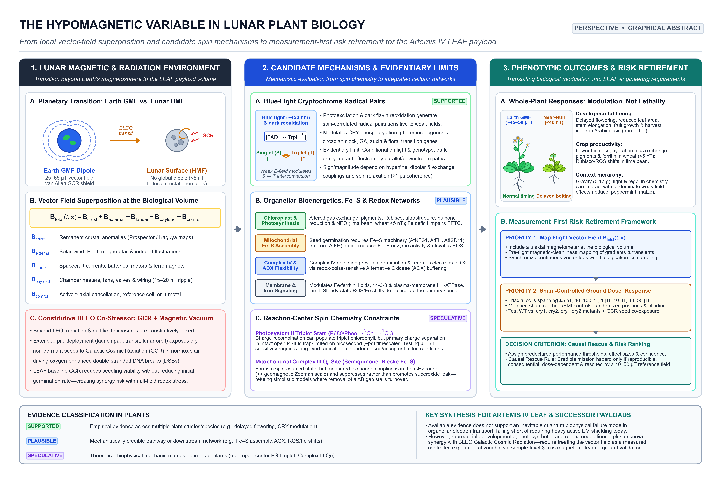
Graphical Abstract | The hypomagnetic variable in lunar plant biology: physical regimes, multiscale candidate mechanisms, and causal-rescue validation for the Artemis III LEAF mission. (Left) Geomagnetic vs. Lunar / BLEO Magnetic Regimes. On Earth and in low Earth orbit (LEO / ISS), plants develop within a dipolar geomagnetic field of ~25–65 µT [1, 8, 9]. Beyond low Earth orbit (BLEO) and on the lunar surface, the global dipole is absent; background fields drop to <5 nT in interplanetary space and typically ≤1–300 nT across most lunar surface regions [2, 5, 10–12], alongside localized crustal anomalies and uncharacterized 50–500 µT DC/AC hardware stray fields, while dormant seeds and seedlings experience chronic galactic cosmic rays (GCRs), solar particle events (SPEs), and lunar ~0.16 g [7, 11]. (Center) Candidate Primary Mechanisms and Evidence Hierarchy. Stratified by empirical support and physical feasibility (Table 1): (i) blue-light-activated cryptochrome (CRY1/CRY2) flavin–tryptophan (FAD•−/TrpH•+) radical-pair spin dynamics (Δg ~ 10⁻³, hyperfine A ~ 0.1–1 mT, τc ~ 100 ns–10 µs), supported in Arabidopsis [13–21, 39]; (ii) mitochondrial Fe–S cluster assembly (AtNFS1, AtFH, AtISD11), Complex IV (COX), and redox-poise-sensitive alternative oxidase (AOX) respiratory flexibility during seed germination [34–38]; and (iii) speculative organellar electron-transfer radical pairs in mitochondrial Complex III (Qo site semiquinone–Rieske [2Fe–2S], GHz exchange coupling J [46, 47]) and chloroplast PSII (P680•+Pheo•−, picosecond charge separation [48, 49]). (Right) Whole-Plant Phenotypes and Causal-Rescue Validation. Organellar and signaling shifts converge on ROS (O2•−, H₂O₂), iron homeostasis (FER1, FRO2, IRT1), circadian clock genes (LHY, PRR7), gibberellin/auxin (IAA/PIN) transport, and photoperiodic flowering (FT, CO) [22–33], validated via 3-axis magnetometry, bifilar sham coils, and ~40–50 µT reference-field rescue (Table 2).

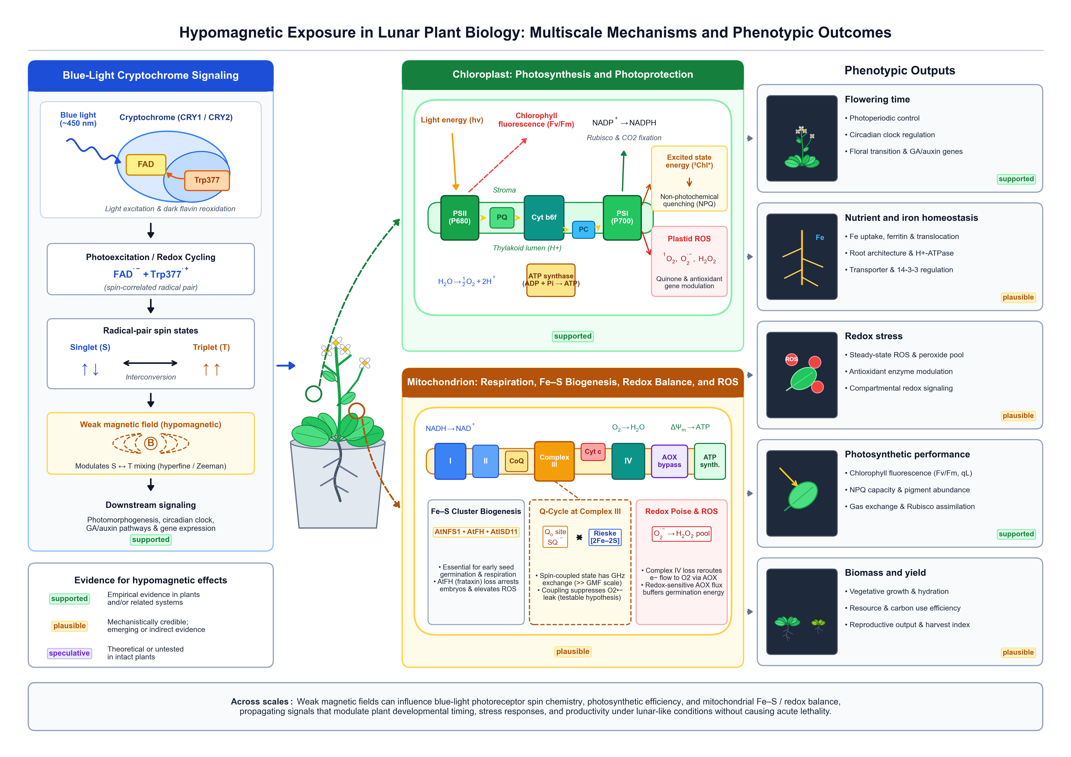Figure 2 | Multiscale conceptual model linking candidate primary magnetoreceptive mechanisms, organellar redox/bioenergetic integration, and whole-plant developmental outcomes under hypomagnetic exposure. (Top Banner) Environmental comparison between Earth's geomagnetic environment (~25–65 µT, 1 g, magnetospheric shielding) and the lunar surface / BLEO regime (≤1 µT, typically <5–300 nT; ~0.16 g; chronic GCRs and SPEs; plus hardware stray fields). (Left Column) Primary biophysical mechanisms: (top) Supported cryptochrome (CRY1/CRY2) radical-pair mechanism ([FAD•− TrpH•+] photoreduction and [FADH• O2•−] dark reoxidation, singlet–triplet S ↔ T0, T±1 mixing at fL ≈ 1.4 MHz vs. <28 kHz) [13–21, 40–45]; (bottom) Non-photoreceptor redox and bioenergetic pathways, distinguishing supported mitochondrial Fe–S assembly (AtNFS1/AtFH/AtISD11) and ETC shifts [34–38] from speculative direct µT spin mixing at Complex III Qo or PSII [46–49]. (Center Column) Organellar integration across the chloroplast (PSII Fv/Fm, NPQ, plastidial ROS, Rubisco RBCL/RBCS, CAB, and plastidial ferritin FER1 [25, 29–33]) and mitochondrion (AtNFS1/AtFH/AtISD11 Fe–S biogenesis, aconitase ACO, Complex IV COX vs. redox-poise-sensitive AOX partitioning, ΔΨm, and ATP synthesis during seed germination [34–38]). (Right Column) Downstream transcriptional/hormonal/nutrient networks (circadian clock LHY/CCA1/PRR7/GI, floral integrators CO/FT, GA and polar auxin PIN1/3/7 transport, and iron uptake FIT/FRO2/IRT1 [13–33]) and whole-plant developmental outcomes (delayed flowering, root growth/gravitropism shifts, leaf photosynthetic shifts, and context-dependent biomass allocation [24–28, 39]).

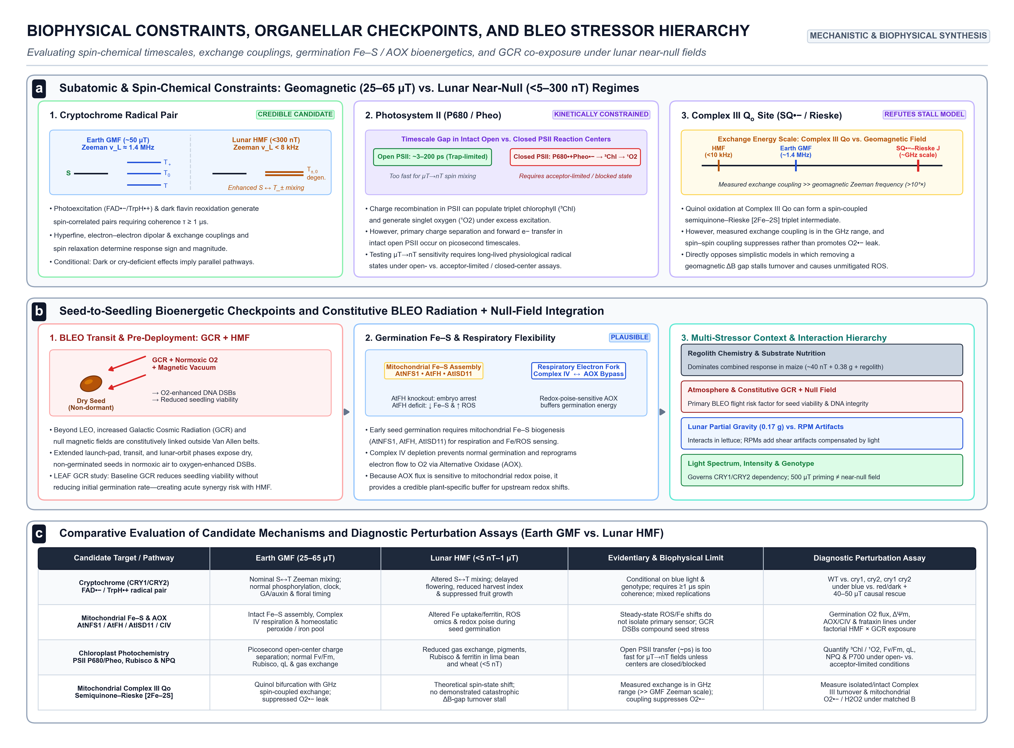
Figure 3 | Biophysical timescale constraints on candidate primary magnetosensors and multi-stressor convergence during BLEO seed transit and early lunar germination. A, Quantitative map of radical-pair spin coherence lifetime (τc, 10⁻¹² to 10⁻³ s) vs. internal exchange or hyperfine coupling (kHz to GHz) relative to the 50 µT Larmor precession period (τL ≈ 714 ns, fL ≈ 1.4 MHz; Table 1). Cryptochrome (CRY1/CRY2) FAD•−/TrpH•+ and FADH•/O2•− radical pairs (τc ~ 100 ns–10 µs, hyperfine A ~ 0.1–1 mT) fall inside the biophysically feasible µT window [13–21, 40–45], whereas PSII P680•+Pheo•− undergoes picosecond charge separation (3–300 ps << τL) [48, 49] and mitochondrial Complex III Qo semiquinone–Rieske [2Fe–2S] pairs experience strong GHz exchange coupling (J >> ωL) [46, 47]. B, Mitochondrial Fe–S cluster biogenesis (AtNFS1–AtISD11 cysteine desulfurase, frataxin AtFH, and ISU1 scaffold supplying [2Fe–2S]/[4Fe–4S] clusters to Complexes I–III and aconitase) and electron partitioning between cytochrome c oxidase (Complex IV, COX) and redox-poise-sensitive alternative oxidase (AOX) under HMF [34–38]. C, BLEO transit and lunar surface multi-stressor convergence during seed germination: quiescent seeds accumulating GCR (H+, HZE) and SPE DNA double-strand breaks (DSBs) and radiolytic ROS in <5 nT deep-space fields undergo imbibition at ≤300 nT and ~0.16 g, where HMF-perturbed AtNFS1/AtFH Fe–S assembly and AOX respiratory flexibility intersect with high ATP/cofactor demand for DNA repair and radicle emergence [7, 11, 34–38].

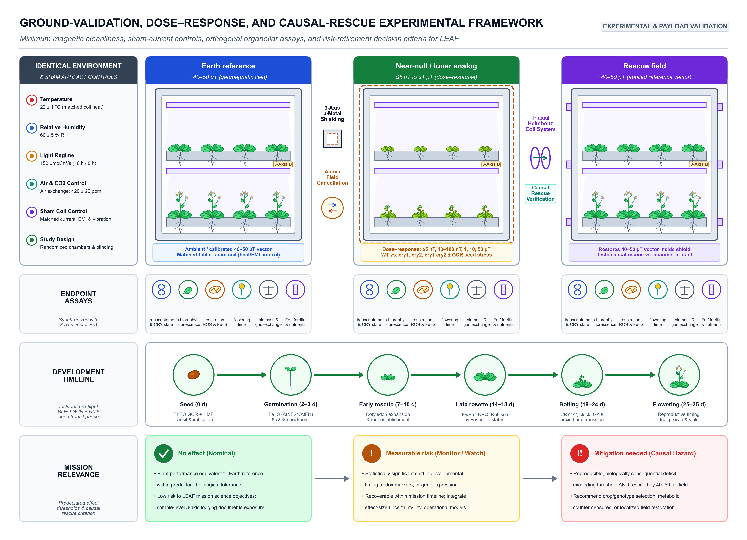
Figure 4 | Standardized ground-validation, dose–response, and causal-rescue experimental framework for retiring hypomagnetic risk in lunar plant payloads. (Top Row) Parallel three-chamber design with identical environmental parameters (22 ± 1 °C, 60 ± 5 % RH, 150 µmol m⁻² s⁻¹ 16 h / 8 h light, 420 ± 20 ppm CO2, matched-current bifilar sham coils, and randomized/blinded assignment; Table 2): (1) Earth reference (~40–50 µT geomagnetic vector + sham coil); (2) Near-null / lunar analog (≤5 nT to ≤1 µT inside 3-axis µ-metal shielding or active cancellation coils, supporting multi-point dose–response testing across WT and cry1, cry2, cry1 cry2 mutants ± GCR seed stress); and (3) Causal rescue field (~40–50 µT reference vector actively restored inside identical shielding via triaxial Helmholtz coils). (Second Row) Six synchronized orthogonal endpoint assays paired with continuous 3-axis vector magnetometry B(t): transcriptomics & CRY state, PAM chlorophyll fluorescence (Fv/Fm, NPQ), mitochondrial respiration (COX/AOX), ROS & Fe–S activity, flowering time, biomass & gas exchange, and Fe/ferritin & nutrient profiles. (Third Row) Staged developmental timeline from Seed (0 d, BLEO GCR + HMF transit & imbibition) and Germination (2–3 d, Fe–S AtNFS1/AtFH & AOX checkpoint) through Early/Late Rosette (7–18 d), Bolting (18–24 d), and Flowering (25–35 d). (Bottom Row) Predeclared mission relevance and decision criteria: No effect (Nominal), Measurable risk (Monitor / Watch), and Mitigation needed (Causal Hazard rescued by 40–50 µT reference field).

